
School of Computer Science and Information Systems
Winter Semester 2025-2026
Agile Development Process and Devops Lab

Course faculty- SWETA BHATTACHARYA
Course Code – ISWE406P
Slot- C1+TC1

TOPIC : Maven
Name: DHINESH.S
Reg no: 23MIS0396

1. Create a Maven Project in Git
• Create a new Git repository
• Create a simple Maven project structure manually, including the following files and folders:
- pom.xml
- src/main/java/com/example/App.java
- src/test/java/com/example/AppTest.java

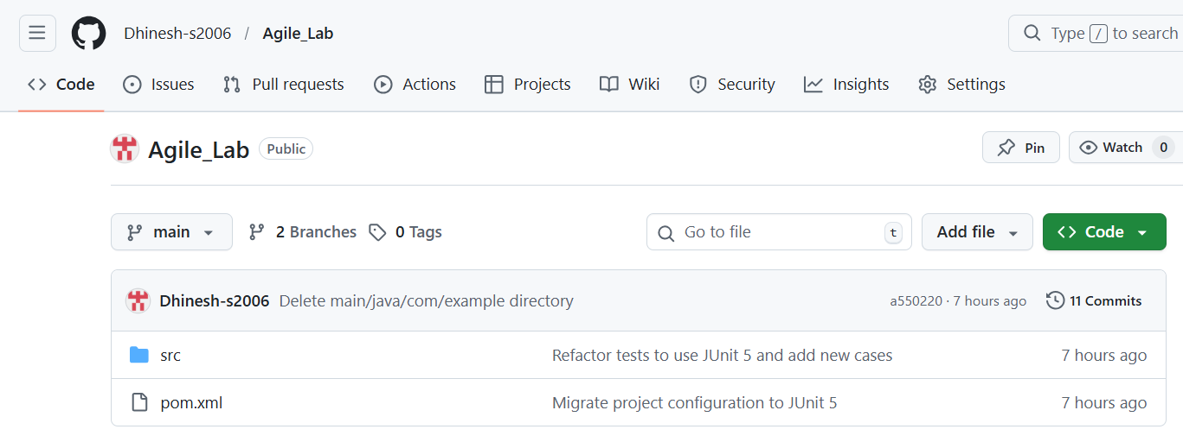

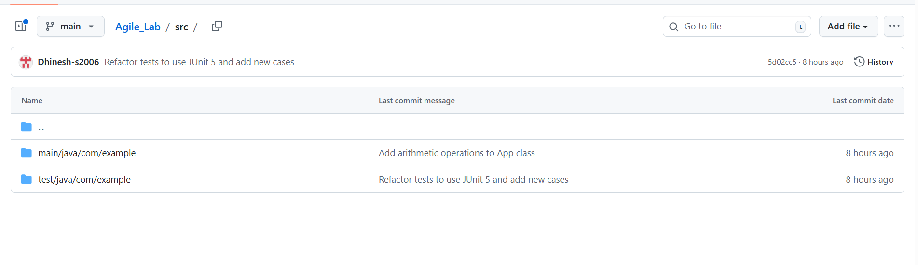

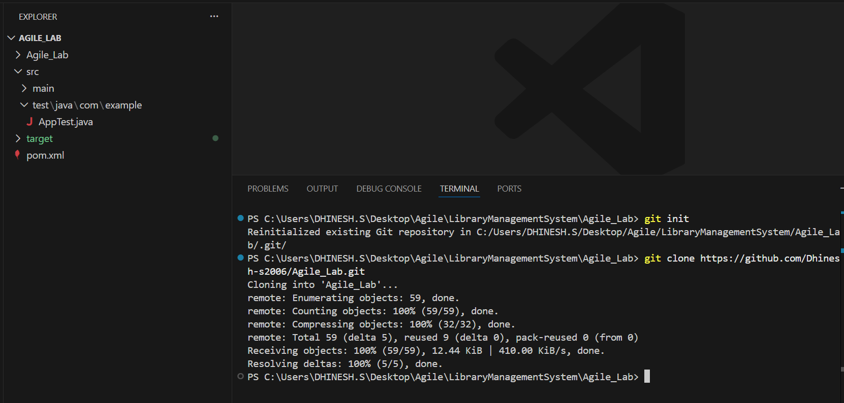

2. Implement the Java Program
• Write a simple Java program in App.java under your newly created Git repository for any one of the following scenarios:
Student Grade Calculator
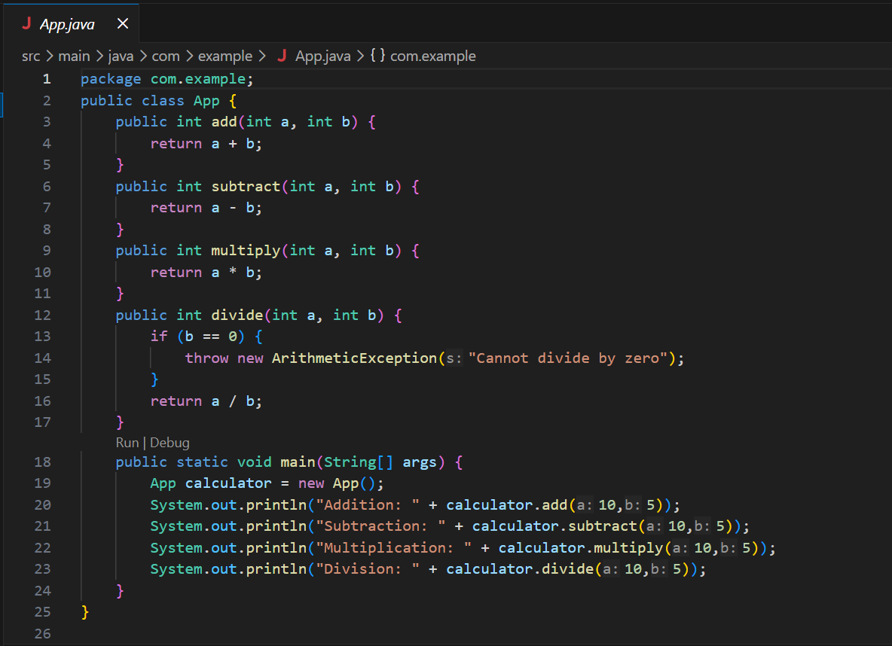
• Write a corresponding unit test in AppTest.java.
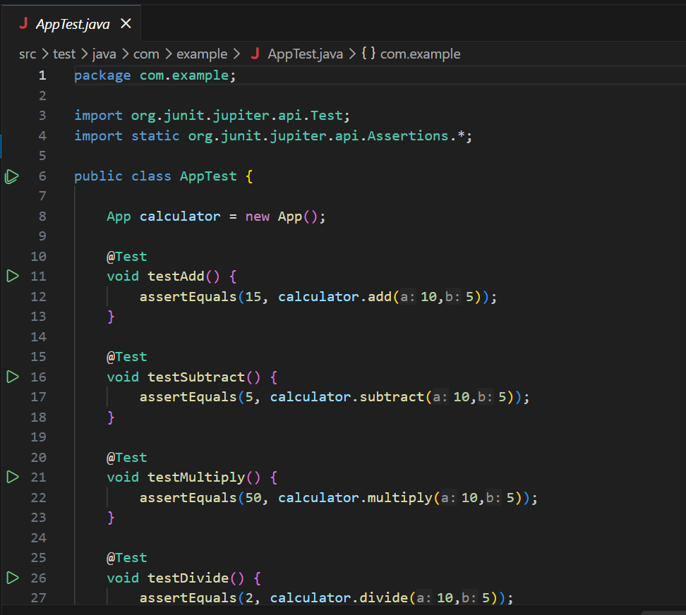

3. Push and Clone the Repository
• Clone the repository using Visual Studio Code.
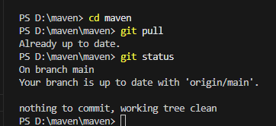

• Verify the project structure.
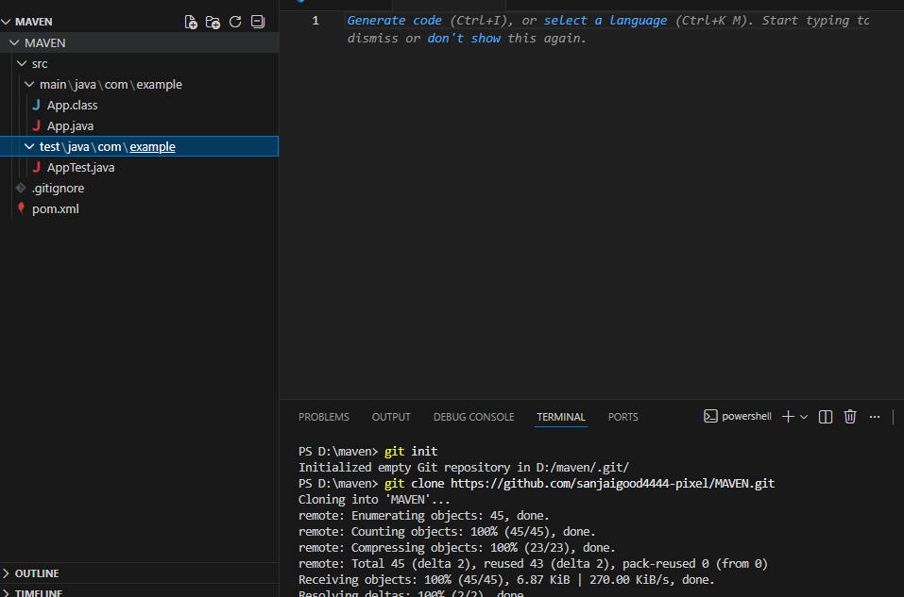

4. Build the Maven Project
• Use Maven commands in Visual Studio Code terminal to:
- Compile the project
- Run tests
- Build the project (mvn clean install)

Compile the project:

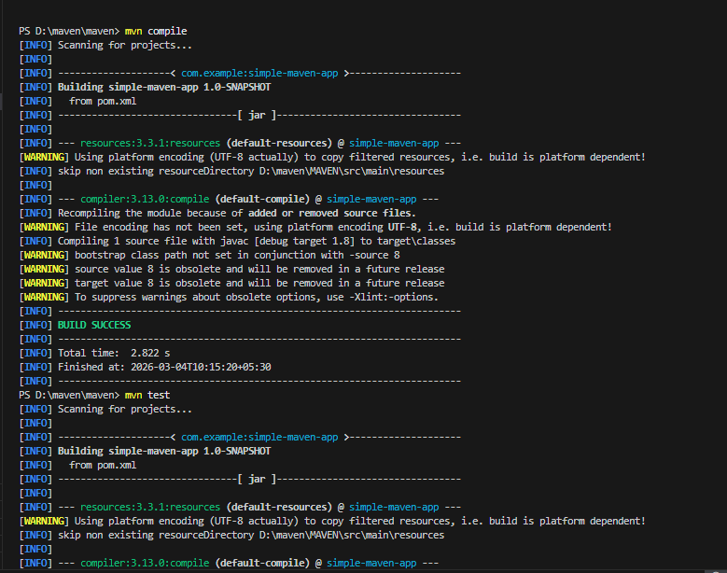

Run tests:
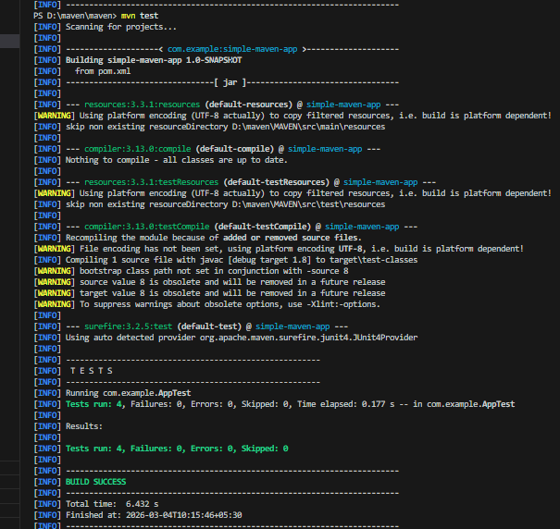
Build the project (mvn clean install):
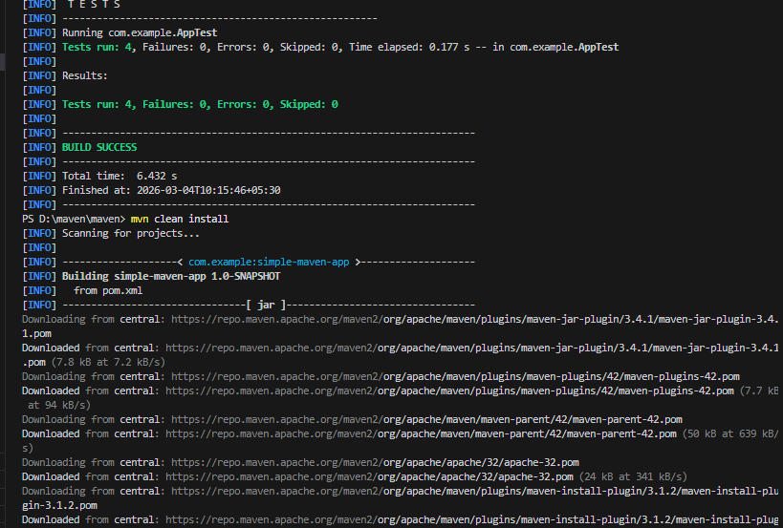

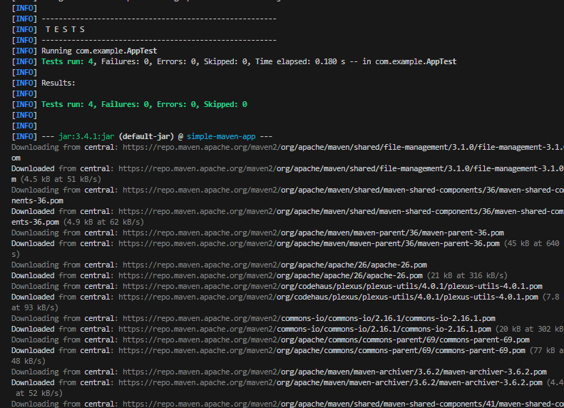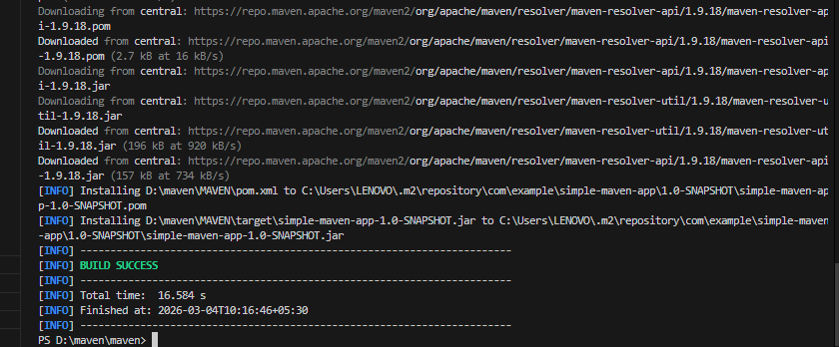

5. Create and Run Jenkins Pipeline
• Create a new Pipeline project in Jenkins.
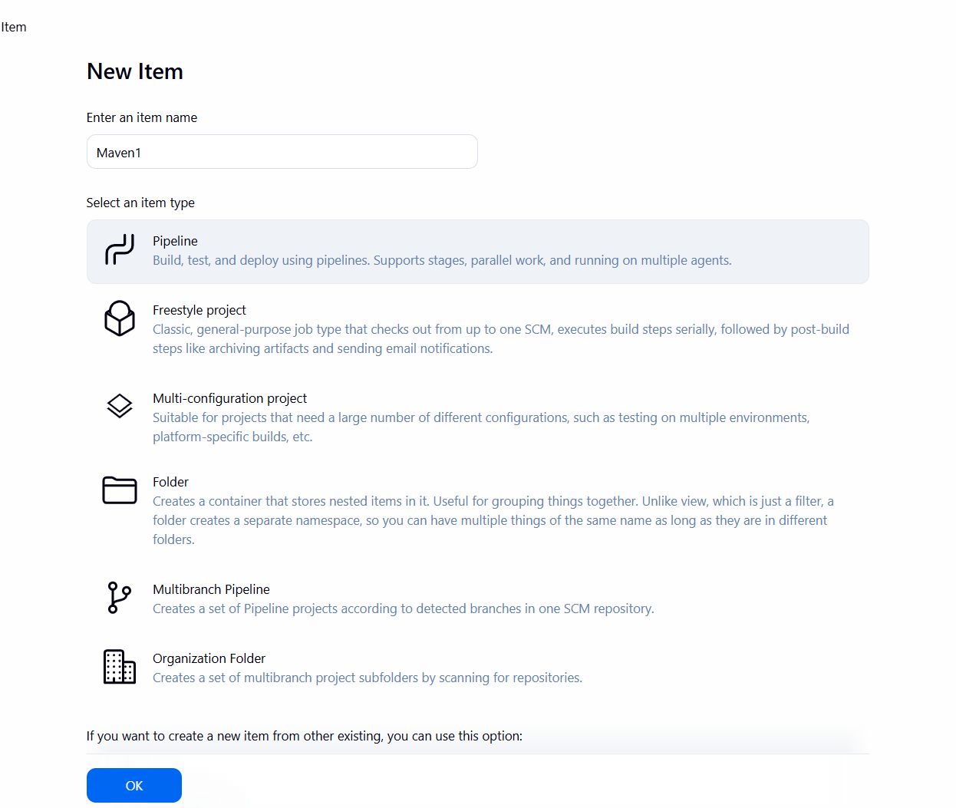

• Create a pipeline script
pipeline {
agent any
tools {
maven 'M3'
}
stages {
stage('Checkout Git') {
steps {
git branch: 'main',
url: 'https://github.com/Dhinesh-s2006/Agile_Lab.git'
}
}
stage('Build and Test') {
steps {
bat 'mvn clean test'
}
}
}
}

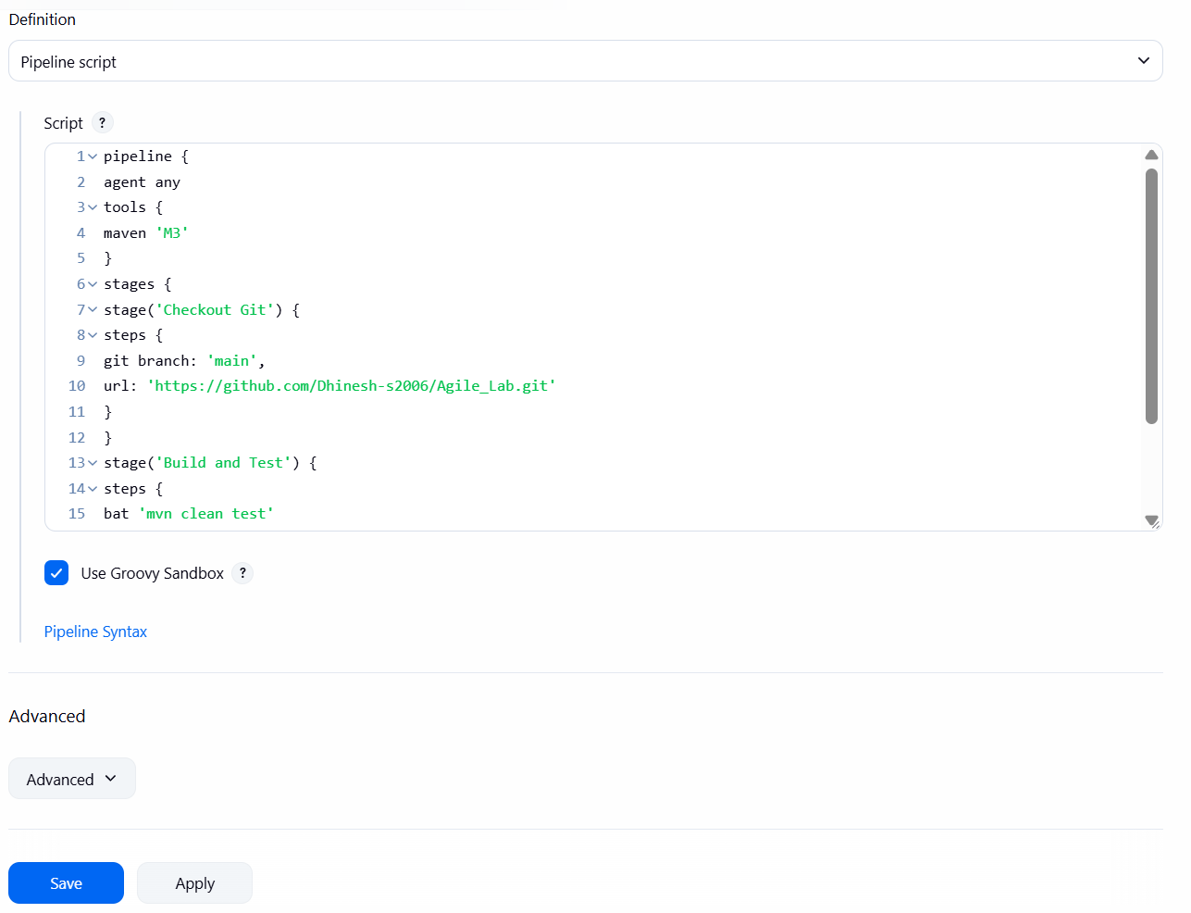

• Execute the pipeline and verify successful build completion.




